[1]

[1] Bedzra R. Finite element simulation of two dimensional orthogonal cutting process and comparison with experiments[D]. GER: RWTH Aachen University, 2013.

**Cutting speed(m/s):**

|  |  |  |
| --- | --- | --- |
| **20m/min** | **40m/min** | **80m/min** |
| 0.333 | 0.666 | 1.333 |

**Workpiece dimension(mm):**

|  |  |  |
| --- | --- | --- |
| **Length** | **Height** | **Feed** |
| 5 | 2 | 0.1 |

**Tool dimension:**

|  |  |  |
| --- | --- | --- |
| **Rake angle(°)** | **Flank angle(°)** | **Radius(μm)** |
| 0 | 10 | 10 |

**Workpiece thermal model and properties:**

The first law of thermodynamics:

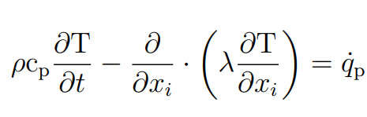

temperature dependent specific heat capacity cp, thermal conductivity λ, and thermal expansion α:

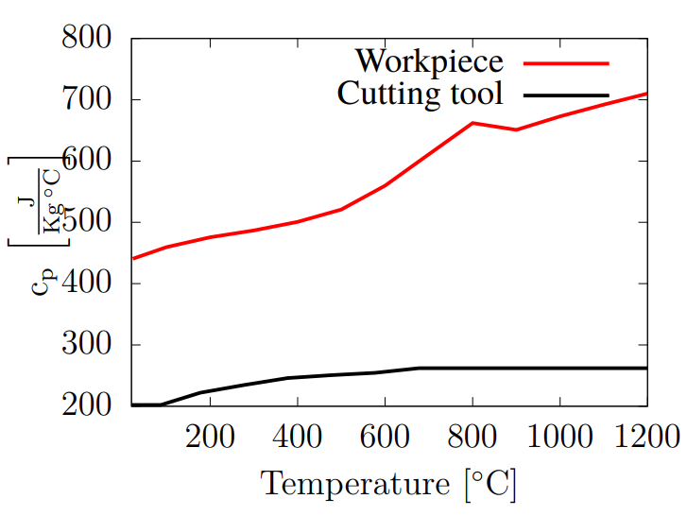

|  |  |  |  |  |  |  |  |  |  |  |  |  |  |
| --- | --- | --- | --- | --- | --- | --- | --- | --- | --- | --- | --- | --- | --- |
| **T (℃)** | 0 | 100 | 200 | 300 | 400 | 500 | 600 | 700 | 800 | 900 | 1000 | 1100 | 1200 |
| **cp(J/(kg·℃))** | 440 | 470 | 480 | 490 | 500 | 520 | 550 | 600 | 660 | 650 | 660 | 700 | 710 |

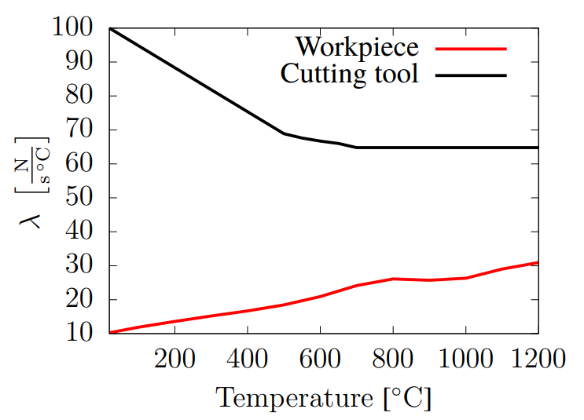

|  |  |  |  |  |  |  |  |  |  |  |  |  |  |
| --- | --- | --- | --- | --- | --- | --- | --- | --- | --- | --- | --- | --- | --- |
| **T (℃)** | 0 | 100 | 200 | 300 | 400 | 500 | 600 | 700 | 800 | 900 | 1000 | 1100 | 1200 |
| **λ(N/(s·℃))** | 10 | 11 | 13 | 15 | 18 | 19 | 21 | 25 | 26 | 25 | 25 | 29 | 31 |

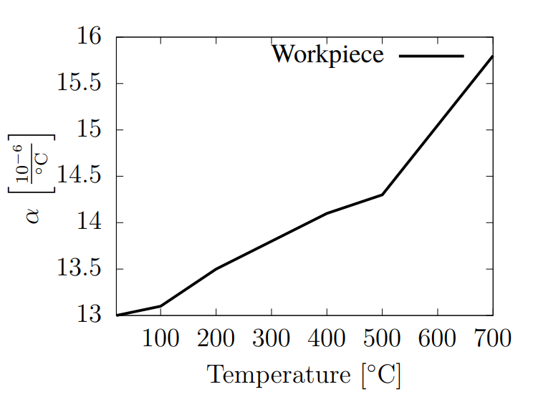

|  |  |  |  |  |  |  |  |  |  |  |  |  |  |  |  |
| --- | --- | --- | --- | --- | --- | --- | --- | --- | --- | --- | --- | --- | --- | --- | --- |
| **T (℃)** | 0 | 50 | 100 | 150 | 200 | 250 | 300 | 350 | 400 | 450 | 500 | 550 | 600 | 650 | 700 |
| **α(10-6/℃)** | 13 | 13.05 | 13.1 | 13.3 | 13.5 | 13.7 | 13.8 | 13.9 | 14.1 | 14.25 | 14.3 | 14.6 | 15 | 15.3 | 15.8 |

density：

ρ = 8.22 × 103 kg/m3

**Workpiece elastic model and properties:**

Hooke’s law:

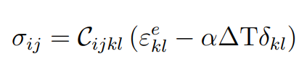

temperature dependent Young’s modulus E and Possion’s ratio **ν**

|  |  |  |
| --- | --- | --- |
| **T (℃)** | **E (GPa)** | **ν** |
| 20 | 217 | 0.3 |
| 871 | 155.9 | 0.3 |

**Workpiece plastic model and properties:**

Johnson-Cook plasticity model:

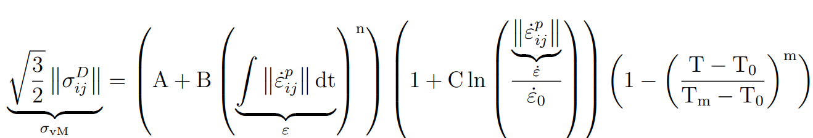

Johnson-Cook flow stress material parameters:

|  |  |  |  |  |  |  |  |
| --- | --- | --- | --- | --- | --- | --- | --- |
| **(1/s)** | **T0 (℃)** | **Tm (℃)** | **A(MPa)** | **B(MPa)** | **C(MPa)** | **n** | **m** |
| 10-3 | 20 | 1297 | 1485 | 904 | 0.015 | 0.777 | 1.689 |

**Chip formation model and properties:**

Johnson-Cook damage model:

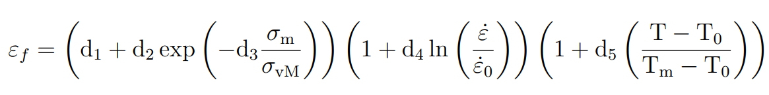

|  |  |
| --- | --- |
| **d2** | **d4** |
| 2.031 | 0.014 |

**Tungsten carbide Tool material properties:**

temperature dependent specific heat capacity cp, thermal conductivity λ, and thermal expansion α, and density:

|  |  |
| --- | --- |
| **ρ(kg/m3)** | **α(10-6/℃)** |
| 15.8× 103 | 540 |



|  |  |  |  |  |  |  |  |  |  |  |  |  |  |
| --- | --- | --- | --- | --- | --- | --- | --- | --- | --- | --- | --- | --- | --- |
| **T (℃)** | 0 | 100 | 200 | 300 | 400 | 500 | 600 | 700 | 800 | 900 | 1000 | 1100 | 1200 |
| **cp(J/(kg·℃))** | 200 | 210 | 220 | 240 | 245 | 250 | 255 | 260 | 260 | 260 | 260 | 260 | 260 |



|  |  |  |  |  |  |  |  |  |  |  |  |  |  |
| --- | --- | --- | --- | --- | --- | --- | --- | --- | --- | --- | --- | --- | --- |
| **T (℃)** | 0 | 100 | 200 | 300 | 400 | 500 | 600 | 700 | 800 | 900 | 1000 | 1100 | 1200 |
| **λ(N/(s·℃))** | 100 | 94 | 90 | 82 | 76 | 69 | 66 | 65 | 65 | 65 | 65 | 65 | 65 |

#### **Simulation result:**

**Cutting and feed force model:**

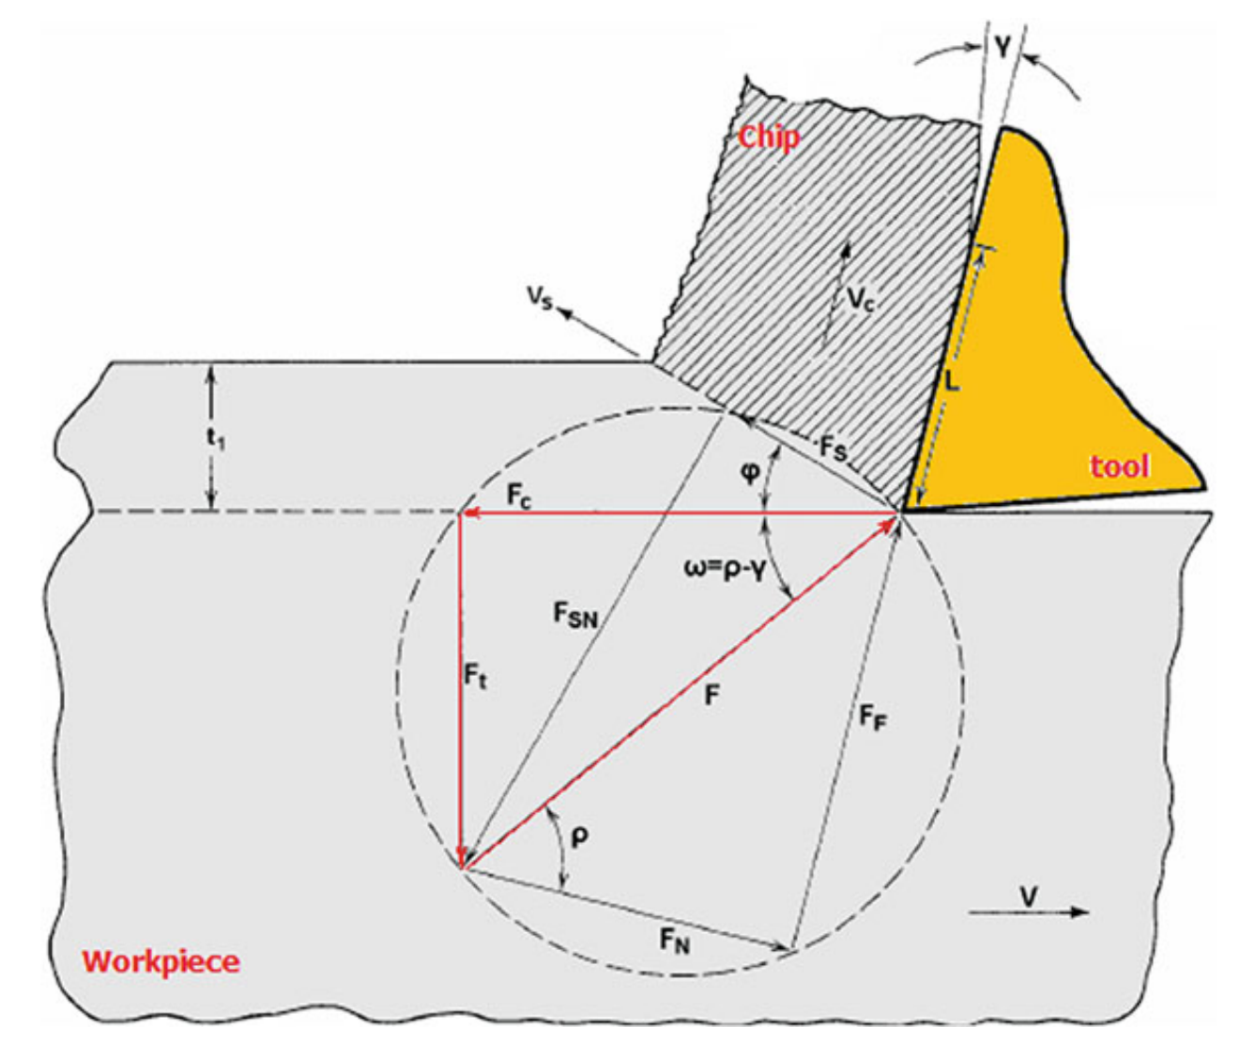

**Cutting force comparison:**

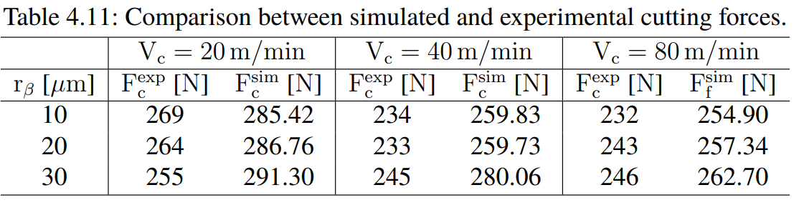

**Feed force comparison:**

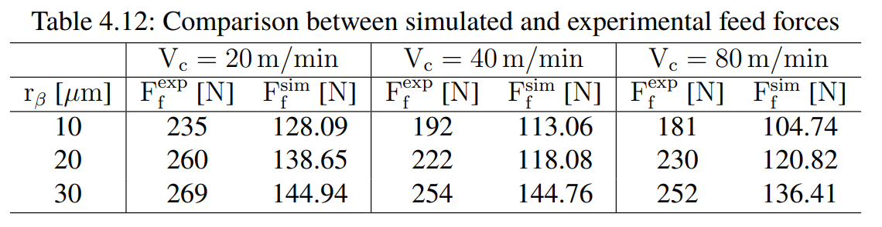

Force:

|  |  |  |  |  |
| --- | --- | --- | --- | --- |
|  |  | **Vc=20m/min** | **Vc=40m/min** | **Vc=80m/min** |
|  | Average  cutting force(N) | 569.53 | 557.52 | 537.16 |
|  | Average  feed force(N) | 247.29 | 270.24 | 264.24 |

|  |  |  |  |  |  |  |  |  |  |  |
| --- | --- | --- | --- | --- | --- | --- | --- | --- | --- | --- |
|  |  | **Vc=20m/min** | | | **Vc=40m/min** | | | **Vc=80m/min** | | |
|  |  | Exp | Sim | My | Exp | Sim | My | Exp | Sim | My |
|  | Average  cutting force(N) | 269 | 285.42 | 569.53 | 234 | 259.83 | 557.52 | 232 | 254.90 | 537.16 |
|  | Average  feed force(N) | 235 | 128.09 | 247.29 | 192 | 113.06 | 270.24 | 181 | 104.74 | 264.24 |

**Chip:**

